TABEL MD

 | Surjective  K<=n  Min o bila/cutie | Injective  N<=k  Max o bila/cutie | Arbitrare  Pot fii si cutii vide | Bijective  N=k
Cd,bd | k!*S(n,k) | K(k-1)…(k-n+1) | k^{n} | n!
Ci,bd | S(n,k) | 1 | 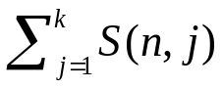 | 1
Cd,bi | 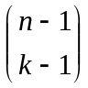 | 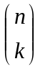 | 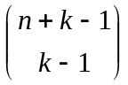 | 1
Ci,bi | P(n,k) | 1 | P(n+k,k) | 1

Cd=cutii diferite bd=bile diferite

